UTM Computing Proceedings
Innovations in Computing Technology and Applications
Volume: 4 | Year: 2026 | ISBN No. :

A Scalable Data Pipeline for Multi-Year Public Sector Salary Analysis Using Apache Spark

Ng Yu Hin
Faculty of Computing
Universiti Teknologi Malaysia
Johor Bahru, Malaysia
nghin@graduate.utm.my

Abstract— With the explosion of open government data, there are many new opportunities for longitudinal public sector analytics. But the diverse nature and increasing size of such data requires powerful, scalable processing systems that go beyond the capabilities of traditional tools. This paper introduces the design and implementation of a distributed data pipeline using Apache Spark, for multi-year salary records of Brazilian public employees in the state of São Paulo (2013 - 2015). The proposed pipeline includes ingesting data from Kaggle's CSV data source, applying rules and transformations to clean the data, storing the data in a columnar format using Parquet files in a Data Lakehouse and querying the data with analytical queries using Spark SQL. Furthermore, an anomaly detection component based on scikit-learn's Isolation Forest was added to further improve the quality assessment of the data, which was applied to a representative sample of the Spark-processed data and re-joined to the distributed data through a generated row identifier. The system is built to solve important data engineering problems such as heterogeneous schemas for annual datasets, handling missing values and efficient partitioned storage. The outcomes should be an end-to-end pipeline that can be reproduced, using industry aligned practices for data engineering and applicable to public sector workforce analytics.
Keywords- Apache Spark; data pipeline; ETL; public sector salary analysis; PySpark; Data Lakehouse; big data; Parquet

INTRODUCTION

Background
The scale and scope of open government data repositories has made public sector data a key asset for empirical socio-economic analysis. Payroll transparency portals provide longitudinal history of public employee payrolls and systematic analysis of this data can identify structural trends in workforce distribution, compensation equity and salary changes over time. There are multi-year records of public employee salaries available from the Government of São Paulo, Brazil, since 2013 on Kaggle. These annual releases are separate comma separated values (CSV) files, with schema variation and integration issues that make it impossible to easily analyze with traditional applications like spreadsheet software or single node relational databases.
Distributed processing frameworks are the answer to such challenges in the field of Data Engineering. In-memory computation model, distributed transformations are natively supported and a large ecosystem including Spark SQL, the DataFrame API and Spark MLlib [1] have made Apache Spark an open-source unified analytics engine that is becoming a de facto standard for large-scale data processing. Its ability to process data in parallel over multiple partitions makes it well suited to the iterative ingestion, cleaning and transformation of multi-year government salary data.

Problem Statement
The Brazilian public sector salary data on Kaggle is a collection of heterogeneous annual CSV files with inconsistent column names, data types and fullness. The raw data is not immediately suitable for analysis because there is no consistent schema and values are missing, duplicated and salary is encoded in different ways. In addition, the total number of records over the years requires a distributed processing model that can scale horizontally without impacting query performance. There is no standard, repeatable process for ingesting, cleansing, merging and loading these annual files into a format that's most useful for temporal salary analysis at this time.

Project Justification
A structured pipeline is needed to reduce repetitive manual data preparation and to create high data fidelity and reusable analytical outputs. The data architecture should be reliable, scalable and maintainable to gain meaningful insights from big data [2]. The decision to use Apache Spark as the main processing technology was driven by the fact that it is a distributed, in-memory computation model specifically engineered to effectively process large-scale data transformations [7]. Moreover, the Data Lakehouse paradigm enables the system to leverage the flexibility of data lakes and the performance optimizations of data warehouses [4]. An AI-based anomaly detection module further automates the intricate process of data quality assessment [3].

Project Goal & Objectives
The primary objective of this project is to create and deploy a scalable end-to-end data pipeline with Apache Spark to automate the collection, transformation and loading of multi-year salary data for the Brazilian public sector for analytical purposes. The specific objectives are as follows:
1. To ingest multi-year public sector salary CSV data sets from Kaggle to a single Apache Spark processing environment.
2. To develop and execute a structured data clean and transform process to address schema inconsistencies, data quality anomalies and normalize salary fields across each iteration.
3. To create a scalable storage solution using the Data Lakehouse architecture with Parquet columnar format for efficient partitioned querying.
4. To add an AI-based anomaly detection step in the pipeline using scikit-learn's Isolation Forest, train the model on a subset of the Gold-layer data and then score the remaining data and re-join the scores to the Spark DataFrame to improve data quality assessment.
5. To test the performance and correctness of the pipeline using structured Spark SQL analytical queries on salary trends, departmental distributions and year-on-year changes in salaries; and to provide the curated Gold-layer outputs via an interactive Power BI dashboard that allows for visualization of the temporal salary trend and auditing of anomalies recorded in the pipeline.

LITERATURE REVIEW

Salary Analysis in Public Sector Data
Salary analysis is the systematic gathering, cleansing and analysis of salary data that can reveal patterns like pay distribution, departmental budget allocation and year-on-year salary patterns [8]. In the public sector, salary analysis usually consists of consolidating salary data over a period of time and across job titles, departments and other categories and then identifying irregularities like unexplained salary increases, salary discrepancies, or budget overruns, which could indicate administrative mistakes or wrongdoing. Public sector salary analysis is not about competitiveness in the market; it's about transparency, auditability and equitable use of public funds because the payroll data shared as part of an open-government initiative is designed to enable citizens and auditors to review how taxpayer money is being spent. This is usually done by summing up the transaction level salary records by department, job position, year, etc. and then calculating descriptive statistics (mean, sum, variance) to create a salary baseline, which can then be used to compare individual records for statistical deviation. This project applies the Gold-layer aggregations (departmental averages, YoY trends) outlined in subsequent sections, along with an anomaly detection layer to automatically detect records that fall outside of the expected departmental and positional compensation baselines.

Data Pipelines and Modern Data Engineering
A data pipeline is a collection of processes that are automated to extract data from source systems, transform it into a useful state and load it into an analytical environment. As noted by Kleppmann [2], modern data-intensive applications need architectures that can accommodate the ever-changing schema and the increasing amount of data within it without compromising reliability. When shifting from classic Extract, Transform, Load (ETL) to Extract, Load, Transform (ELT), raw data can be safely persisted first and then complex transformations applied, reducing the risk of data loss due to pipeline failures.

Distributed Processing with Apache Spark
Processing multi-year governmental datasets requires robust computational frameworks. Zaharia et al. [7] introduced Apache Spark as a unified engine for big data processing, utilizing Resilient Distributed Datasets (RDDs) to allow fault-tolerant, in-memory computations. By utilizing PySpark, complex operations such as cross-year joins, aggregations and window functions can be distributed across multiple nodes. Furthermore, Dritsas and Trigka [1] demonstrated that applying machine learning models directly within the Apache Spark ecosystem yields significant scalability advantages, allowing algorithms to process massive datasets in parallel. A principle this project applies by combining Spark's distributed StringIndexer-based feature encoding with scikit-learn's Isolation Forest, executed on a sampled subset of the data and rejoined to the full Spark DataFrame.

Data Quality Assessment Systems
Data quality is central for reliable public sector analytics. Wang et al. [3] successfully proposed a rule-based data quality assessment system for electronic health records, demonstrating that applying systematic rule templates can expose hundreds of thousands of discrepancies that would otherwise skew analysis. This project adopts a similar methodology, transposing rule-based validations such as null thresholds, standardizing decimal separators, to the Brazilian salary dataset using PySpark DataFrame functions.

Isolation Forest for Unsupervised Anomaly Detection
Isolation Forest is an unsupervised machine learning algorithm designed specifically for anomaly detection, introduced by Liu, Ting and Zhou [9]. Unlike distance- or density-based outlier detection methods, Isolation Forest operates on the principle that anomalies are "few and different," and are therefore easier to isolate than normal observations. The algorithm constructs an ensemble of random binary trees or isolation trees by recursively partitioning the data through randomly selected features and split values. Due to anomalous points lie in low-density regions of the feature space, they tend to require fewer partitions to be isolated into their own leaf node, resulting in a shorter average path length across the ensemble of trees. Each record is assigned an anomaly score derived from this average path length. In hindsight, shorter paths indicate a higher likelihood of being anomalous. This approach offers linear time complexity and low memory overhead relative to distance-based methods such as k-nearest neighbours, making it well-suited to large-scale tabular data such as multi-year salary records. Since the algorithm requires no labelled training data, it is particularly appropriate for this project, where no ground-truth annotations exist to identify fraudulent or irregular compensation records within the Brazilian public sector dataset.

The Data Lakehouse Architecture
Traditional data architectures often force a compromise between the schema-on-read flexibility of Data Lakes and the ACID transactional guarantees of Data Warehouses. Armbrust et al. [4] articulate the benefits of the "Data Lakehouse," a new generation of open platforms that unifies these approaches. By utilizing the open Parquet format, a columnar storage format that vastly improves read-heavy analytical workloads by scanning only necessary columns. The proposed system ensures high-performance querying for temporal salary trends.

The Waterfall Software Development Model
The Waterfall model is a sequential software development methodology in which a project progresses through a fixed series of discrete phases such as requirements analysis, design, implementation, testing and deployment, with each phase expected to be completed before the next begins [10]. Originally formalized by Royce, the model assumes that requirements and system constraints can be fully defined at the outset of a project, allowing subsequent phases to proceed with minimal revision. Each phase produces a specific set of deliverables such as requirements documentation, architectural diagrams and tested code, that serve as the formal entry criteria for the following phase, creating a traceable and auditable development record. The model is best suited to projects where the technology stack, data sources and expected outputs are already known in advance. Since it offers limited flexibility for iterative discovery once implementation has begun. This project adopts the Waterfall model because the dataset (three fixed annual CSV files), processing technology (PySpark), target architecture (Medallion Lakehouse) and analytical outputs (Power BI dashboard) are all explicitly defined prior to development, making an iterative or agile approach unnecessary for managing scope uncertainty.

METHODOLOGY

Selected Methodology
This project adopts an adapted Waterfall system development lifecycle integrated with the principles of Design Science Research (DSR) [5]. DSR is highly appropriate for data engineering projects as it focuses on the systematic construction and rigorous evaluation of an IT artifact. In this case, a scalable data pipeline designed to resolve heterogeneous data integration challenges. A sequential Waterfall approach was utilized to guide the actual development process. While a strictly rigid sequence can sometimes introduce limitations, a phased progression is highly effective for this project because the core dataset, technological stack which is the Apache Spark, target architecture which is the Medallion Data Lakehouse and expected analytical outputs are explicitly defined prior to development. The project progresses through five sequential phases: Requirements Analysis, System Design, Implementation, Testing and Deployment and Presentation.

Justification of Waterfall Methodology
The Waterfall framework is selected because all foundational elements of this project are explicitly predetermined prior to development. The data inputs consist of three known annual CSV files sourced from Kaggle. The processing part was executed using PySpark DataFrames within Google Colab and the target architecture which is a Medallion Data Lakehouse on Google Drive that is fixed from the outset. Since the project scope, technology stack and expected deliverables require no iterative discovery, a sequential phased approach is most appropriate. Establishing architectural blueprints that includes data lineage mappings, entity-relationship diagrams and testing parameter, before initiating implementation minimizes the risk of structural rework and ensures a traceable, auditable development process.

Waterfall Methodology Phases

Requirements Analysis
During the initial phase, the project scope, business objectives and technical constraints was thoroughly defined. The structural composition of the annual Brazilian public sector salary datasets are analyzed to identify schema variations across the 2013, 2014 and 2015 releases. Potential data quality anomalies are documented, including the absence of native primary keys, the presence of duplicate compensation records, inconsistent Brazilian Real (BRL) currency formatting such as comma-based decimals and missing municipal data.

System Design
The constraints and requirements identified in the first phase are translated into comprehensive technical blueprints. Visual architectures are drafted, including a use case diagram detailing user interactions and a data architecture diagram illustrating the flow of data through the Bronze, Silver and Gold storage layers. Because the raw data lacks native identifiers, an entity-relationship design was conceptualized to guide the generation of surrogate keys, ensuring the flat files can be accurately modeled for analytical querying. Finally, the testing criteria and dashboard visualization layouts are planned.

Implementation
The end-to-end data pipeline was constructed during the Implementation phase. Google Colab was configured as the primary development environment, initializing a SparkSession connected to Google Drive for file access. PySpark scripts were used to extract the raw CSVs into DataFrames, enforce unified schemas and write the immutable records to the Bronze layer. Subsequent transformations cleaned the data, generated surrogate keys and persisted the refined tables in the Silver layer. Finally, the Gold layer integrated the data, after which scikit-learn's Isolation Forest algorithm was applied to a 10% sample of the integrated features, with the scored results rejoined to the full Spark DataFrame via a generated row identifier. Features such as gross salary, position index and department index were extracted and evaluated to flag statistical outliers before the final Parquet datasets were written.

Testing
Rigorous evaluation occurs in the Testing phase to ensure the pipeline meets data engineering standards. Each stage of the Medallion architecture was validated against expected outcomes. Test runs were to confirm successful file ingestion, exact duplicate removal, accurate string-to-float currency conversions and the proper handling of null values. Particular emphasis was placed on join-integrity testing; because surrogate keys are generated programmatically, row counts before and after table integrations must be verified to prevent the accidental multiplication of salary transaction records. Any discrepancies discovered during testing are debugged and re-evaluated.

Deployment and Presentation
In the final phase, the completed pipeline and its generated artifacts are prepared for delivery. The finalized PySpark notebook, the structured Parquet files residing in the Bronze, Silver and Gold directories and the flagged anomaly datasets are connected to Power BI. A functional dashboard highlighting temporal salary trends, departmental comparisons and detected outliers are assembled to demonstrate the real-world analytical value of the processed data.

Data Source Identification
The Public Employees Salaries from Brazil–São Paulo dataset was obtained from the Kaggle open data platform. Because the project requires multi-year longitudinal analysis, three distinct annual releases from this repository were ingested. The raw dataset consists of flat CSV files, meaning all employee, department and salary information is denormalized into single records. The selected data sources are detailed in Table I.
- Source Datasets
Dataset | Main contents | Purpose
2013_Salaries.csv  (2013_merged.csv) | Employee names, roles, departments and 2013 monthly salary figures. | Baseline temporal data source.
2014_Salaries.csv  (2014_merged.csv) | Employee names, roles, departments and 2014 monthly salary figures. | Sequential year integration and schema validation.
2015_Salaries.csv | Employee names, roles, departments and 2015 monthly salary figures. | Final longitudinal year for YoY trend analysis.

Due to the fact that the raw open-government CSV files do not contain native unique identifiers such as an Employee ID or Department ID, surrogate keys were generated programmatically during the PySpark transformation phase to establish relationships.

An EMPLOYEE_ID were be generated by hashing the NAME, POSITION and DEPARTMENT columns, while a DEPARTMENT_ID were be generated by hashing the DEPARTMENT column. Employees are connected to Salaries through EMPLOYEE_ID. Departments are connected to Salaries through DEPARTMENT_ID. Dates are connected to Salaries through MONTH and YEAR. Salaries form the main transaction structure, while Employees, Departments and Dates provide descriptive information. The relationships were checked before integration is executed.

Data Ingestion Plan
The raw annual CSV files were hosted in Google Drive and programmatically ingested into Spark DataFrames utilizing PySpark. During this initial extraction phase, the datasets underwent foundational profiling. The pipeline systematically verifies file availability, standardize delimiters, enforce expected schemas via StructType and assess overall row counts and missing values. Furthermore, because the raw files lack native primary identifiers, the programmatically engineered surrogate keys which are EMPLOYEE_ID and DEPARTMENT_ID was mapped and rigorously validated for referential integrity before any cross-year joins or table integrations are executed.

Considering the computational limitations of the Google Colab development environment, the full Bronze-to-Silver ETL pipeline by encompassing ingestion, cleaning, key generation and Gold-layer aggregation across all 37 million records was processed at full volume without sampling, since these stages operate through Spark's distributed, partition-based execution and do not require the dataset to reside in driver memory at once.
Sampling was only required at the Artificial Intelligence stage, where scikit-learn's Isolation Forest must run on data pulled into driver memory via .toPandas(). Because pulling the full 37 million rows to the driver would exceed available RAM, a flat 10% random row-level sample (seed=42) was extracted instead, yielding approximately 3.74 million records for model training and scoring. A stratified, department-based sampling approach was considered as an alternative by selecting a subset of departments and retaining all of their monthly records across 2013–2015 to preserve relational and longitudinal completeness but a flat random sample was used in the final implementation for simplicity, since the anomaly detection task evaluates individual transaction-level outliers rather than department-level time trends, making full relational completeness per department less critical at this stage than at the aggregation stage.

Data Processing and Transformation

Bronze Layer
The three ingested annual salary datasets (2013, 2014, 2015) was persisted in their unmodified structural state within the Bronze layer. By saving the data in its raw form, a reliable recovery point is established, source record counts are preserved for auditing and the initial extraction process is safely isolated from complex downstream modifications. These baseline datasets were written efficiently using the Parquet format.

Silver Layer
The Silver layer functions as the repository for cleaned, standardized and validated public sector records. PySpark transformations was executed to remove exact duplicated rows and filter out records missing critical identifying information. Specifically, Brazilian Real (BRL) monetary strings utilizing comma-based decimal separators were programmatically corrected and converted into proper floating-point numerics to allow for mathematical aggregation. Furthermore, the surrogate keys, EMPLOYEE_ID and DEPARTMENT_ID, are engineered and appended to the records during this phase to standardize relationships.

Gold Layer
The Gold layer contains the business-ready datasets optimized for longitudinal analysis. The refined Silver datasets were systematically joined using their generated surrogate keys. Join conditions were rigorously tested to ensure cross-year transaction records are not accidentally multiplied. The Gold outputs encompass the final multidimensional hybrid star schema, featuring integrated annual salary transactions, departmental compensation averages, year-on-year financial trends and AI-flagged anomaly results ready for dashboard ingestion.

Data Storage
Google Drive serves as the physical storage environment, managed logically through a Data Lakehouse architecture [4]. The pipeline directories were structured systematically as /data/bronze, /data/silver, /data/gold and /data/output. The Bronze directory secured the raw ingested schemas, the Silver directory contained the cleaned intermediate tables and the Gold folder housed the aggregated hybrid/denormalized star schema model. Apache Parquet were deployed as the primary file format across the Medallion layers due to its highly efficient columnar compression, which significantly accelerates analytical read queries. However, specific aggregated tables and anomaly subsets in the output directory may be exported as CSV files to facilitate seamless import into Power BI for final visualization.

Artificial Intelligence Algorithm
An unsupervised anomaly detection approach is strictly required for this dataset because the open-government salary records contain no predefined labels identifying fraudulent or irregular compensation. Without ground-truth annotations, supervised classifiers such as logistic regression or random forests cannot be applied. Isolation Forest is selected as the algorithm of choice for three reasons: it is specifically designed for anomaly detection on tabular numerical data, it operates efficiently on high-dimensional feature spaces without requiring distance calculations and its tree-based isolation mechanism scales well to the volume of multi-year salary records present in the Gold layer.
Three features were extracted from the integrated Gold-layer dataset for model input: the standardized GROSS_SALARY as the primary quantitative signal and vectorized representations of POSITION and DEPARTMENT as categorical context features. These features are selected because statistically irregular salaries are most meaningful when evaluated in relation to the employee's role and organisational unit, a high salary that is anomalous for a junior clerical role may be entirely normal for a senior administrative director.
Since Spark MLlib does not natively include Isolation Forest, the algorithm was implemented using scikit-learn. Because scikit-learn models operate on data resident in driver memory rather than distributed Spark partitions, a 10% random sample (seed=42) of the encoded Gold-layer records, approximately 3.74 million of the full 37 million rows was extracted via a .toPandas() call for model training and scoring. This sampling step was necessary because a full .toPandas() conversion of the complete dataset would exceed the available driver memory in the Google Colab environment. The fitted model's predictions were then rejoined to the distributed Spark DataFrame using a stable row identifier generated by monotonically_increasing_id(), via an inner join. The output of this module is a boolean IS_ANOMALY flag appended to each of the ~3.74 million scored Gold-layer salary records; because the join was an inner join, only sampled and scored rows carry the flag and are retained in the final fact_salaries_anomaly output, equipping auditors in the Power BI dashboard with a programmatic filter to investigate the most statistically isolated compensation payouts.

SYSTEM DESIGN AND ARCHITECTURE

System Design
The designed system is composed of six distinct modules, as outlined in Table II. These components are integrated to form an end-to-end data pipeline. Defining specific operational boundaries for each module ensures that the data lineage, from raw extraction to final visualization, remains transparent, structured and manageable.
- System Modules
Module | Function
Data Source | Supply the three multi-year Brazilian public sector salary CSV datasets.
Data Ingestion | Extract and programmatically validate the raw datasets utilizing PySpark.
Data Storage | Manage the persistence of the Medallion layers (Bronze, Silver, Gold) utilizing the Parquet format.
Data Processing | Execute data cleansing, surrogate key generation, schema integration and business aggregations.
Artificial Intelligence | Encode salary and categorical features via PySpark StringIndexer, apply scikit-learn's Isolation Forest to a 10% sample brought to the driver and rejoin scored results to the Spark DataFrame for outlier detection.
Data Consumption | Serve the finalized multidimensional tables to Power BI for interactive visual analytics.

The Data Source Module supplied the three raw, open-government CSV files extracted from Kaggle (2013, 2014, 2015). Subsequently, the Data Ingestion Module programmatically loaded these files, enforcing schema structures and validating initial record counts. The Data Storage Module oversees the physical Lakehouse directories, ensuring data is safely and efficiently persisted across the Bronze, Silver and Gold Parquet layers. Following this, the Data Processing Module handles the core PySpark transformations, including duplicate removal, currency standardization and the generation of surrogate relationships. The Artificial Intelligence Module applies scikit-learn's Isolation Forest to a representative sample of the Gold-layer data, rejoining the flagged results back to the full Spark DataFrame, to identify statistically irregular compensation records. Finally, the Data Consumption Module was connected to the enriched, anomaly-flagged datasets to Power BI, delivering accessible dashboards and comprehensive analytical reports for end-users.

Use Case Diagram

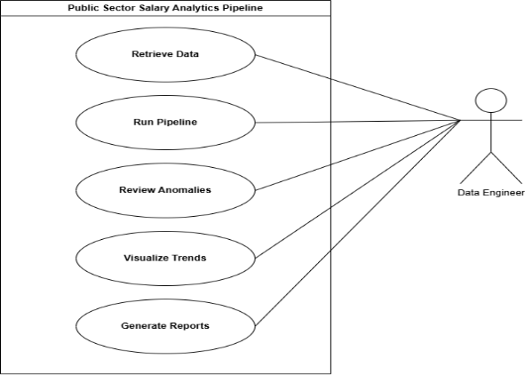
- Use Case Diagram for the Public Sector Salary Analytics Pipeline.
As illustrated in Fig. 1, the use case model is driven entirely by a single primary actor which is the Data Engineer. Rather than mapping granular programmatic functions, the diagram establishes the system boundary by highlighting the five high-level objectives the engineer accomplishes through the platform. First, the actor interacts with the system to Retrieve Raw Salary Data, acquiring the 2013–2015 annual releases from the Kaggle repository. Following this, the engineer triggers the system to Run Distributed ETL Pipeline. This major use case encapsulates the entire technical backend workload, including PySpark schema validation, surrogate key generation and the orchestration of the Bronze, Silver and Gold Medallion layers.
Additionally, the engineer interacts with the intelligent layer of the pipeline to Review Flagged Anomalies, evaluating the specific irregular compensation records isolated by the unsupervised machine learning model. For final data consumption, the actor can Visualize Temporal Salary Trends through integrated Power BI dashboards to analyze departmental financial metrics and subsequently Generate Audit Reports to export these insights as accessible documents. Micro-operations, such as correcting decimal strings or partitioning Parquet files, are intentionally excluded from the visual diagram; these are automated, internal system mechanics rather than independent, human-driven goals.

Data Architecture

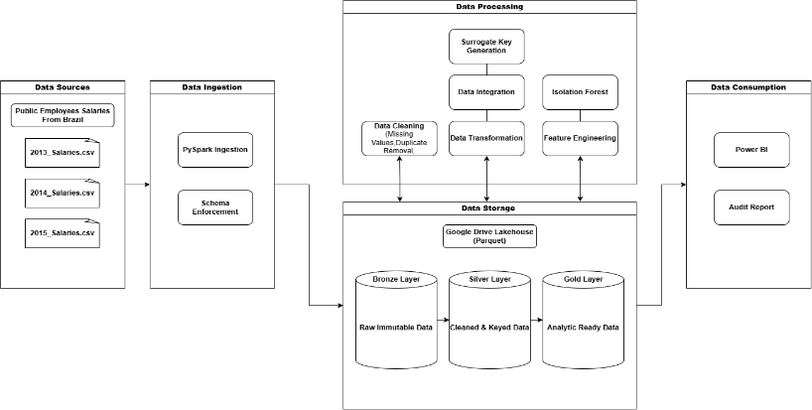
- Data Architecture Diagram for the Public Sector Salary Analytics Pipeline.
As depicted in Fig. 2, the architectural framework is divided into five distinct functional layers, emphasizing a strict separation between compute processing and physical storage. The pipeline initiated at the Data Source layer, which supplied the three annual Brazilian public employee salary CSV datasets from Kaggle. These raw files flowed into the Data Ingestion layer, where PySpark executed the initial extraction and enforced explicit schema mapping.
To ensure fault tolerance and scalability, the architecture utilized a robust Extract, Load, Transform (ELT) pattern, where data iteratively cycled between Data Storage hosted on Google Drive and PySpark Data Processing & AI operations. First, the ingested records were safely persisted into the Bronze Layer as immutable, raw Parquet files. The processing engine then read this Bronze data, applied structural cleaning and BRL currency formatting and loaded the refined results into the Silver Layer. Next, PySpark extracted the Silver records to generate surrogate keys, EMPLOYEE_ID and DEPARTMENT_ID and integrated the data into highly structured, aggregated analytical tables, which were saved into the Gold Layer. Within this same processing tier, scikit-learn's Isolation Forest algorithm was applied to a 10% random sample drawn from the Gold Layer's encoded features, evaluating them for statistical irregularities before rejoining the resulting is_anomaly flags back to the Gold storage via a generated row identifier.
Finally, the pipeline culminates at the Data Consumption layer. Power BI connects directly to the enriched Gold Parquet tables, seamlessly translating the curated data into interactive dashboards and comprehensive audit reports for departmental salary analysis and anomaly investigation.

Pipeline Implementation
The technical execution of the data pipeline was developed using Python within a Google Colab environment, utilizing the PySpark API to handle distributed data processing. The implementation workflow is systematically divided into the following sequential operations:

Environment Configuration and Data Extraction
The implementation was commenced by initializing a SparkSession and mounting the Google Drive environment to access the Kaggle CSV files. To ensure strict data governance, Spark’s inferSchema option was set to False. Instead, a custom PySpark StructType was explicitly defined to enforce correct data types such as StringType for names, FloatType for salaries, during the extraction of the 2013, 2014 and 2015 datasets.

Bronze Layer Persistence
Immediately following extraction, the raw DataFrames are written directly to the /data/bronze directory in Parquet format. This programmatic step guarantees a tamper-proof repository of the original public sector records.

Silver Layer Cleansing and Key Engineering
The core ETL logic was implemented within the Silver layer. Missing values in mandatory fields were removed using the dropna() function, while duplicate transaction rows are filtered via dropDuplicates(). To correct the Brazilian Real (BRL) currency formatting, PySpark’s regexp_replace function was applied to swap comma decimals with standard periods, allowing them to be accurately cast as floats. Crucially, the pipeline utilized the sha2() hashing function, combining the NAME, POSITION and DEPARTMENT strings to programmatically engineer the EMPLOYEE_ID and DEPARTMENT_ID surrogate keys.

Gold Layer Integration
The cleansed DataFrames are integrated into the final analytical model using PySpark join() operations based on the newly generated surrogate keys. Spark SQL's Window functions were utilized to calculate aggregated business metrics, such as the total departmental budget and year-over-year compensation growth.

AI Model Execution
The anomaly detection module was executed immediately after the Gold-layer aggregations are finalized and before the final Parquet write. The technical execution proceeds in the following sequence.
First, the integrated Gold-layer Spark DataFrame was read into memory and the categorical columns POSITION and DEPARTMENT were numerically encoded using PySpark's StringIndexer, producing POSITION_IDX and DEPARTMENT_IDX columns respectively. Second, a stable row identifier (ROW_ID) was generated using monotonically_increasing_id() to support rejoining scored results later. Third, the three feature columns (GROSS_SALARY, POSITION_IDX, DEPARTMENT_IDX) together with ROW_ID were extracted, filtered for nulls and reduced to a 10% random sample (seed=42) via a .toPandas() call, bringing approximately 3.74 million rows to the driver node for scikit-learn processing, a sampling step necessary to keep the 37-million-row full dataset from exceeding Colab's available driver memory. Fourth, a scikit-learn IsolationForest instance was configured with n_estimators=100 and a contamination threshold of 0.05, representing an expected 5% outlier proportion in the dataset. Fifth, the model's fit_predict() method was called on the feature matrix; records scored -1 are flagged as anomalies, while records scored 1 are considered normal. Sixth, the prediction results were mapped to a boolean IS_ANOMALY column and rejoined to the Spark DataFrame using an inner join on ROW_ID, which means only the 3.74 million sampled and scored records, not the full 37 million Silver-layer transactions, appear in the final anomaly-flagged Gold output. Finally, the anomaly-flagged DataFrame was written to the /data/gold directory, partitioned by YEAR, completing the Gold layer pipeline.

Final Lakehouse Loading
The fully integrated, anomaly-flagged datasets are written to the /data/gold directory. The PySpark partitionBy("YEAR") function was applied during this write process, ensuring that the Parquet files are physically partitioned by year to drastically optimize query performance when the data is finally loaded into Power BI.

Database Design

Data Source Entity-Relationship Diagram
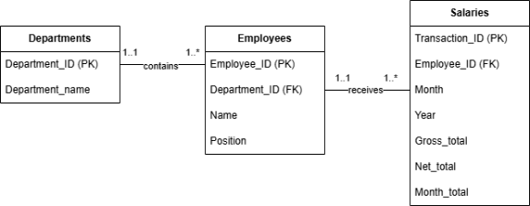
- Entity-Relationship Diagram for the source datasets.

Three core entities are established within the data model which includes Departments, Employees and Salaries. The Departments entity is linked to the Employees entity via the DEPARTMENT_ID surrogate key; this association represents a one-to-many relationship, as a single municipal department inherently employs multiple staff members. The Departments entity also carries a DEPARTMENT_EN attribute, an English-language translation of the original Portuguese DEPARTMENT value, added during Silver-layer processing to support English-language reporting and dashboard readability. Subsequently, the Employees entity is connected to the Salaries entity through the EMPLOYEE_ID. This also forms a one-to-many relationship, given that one individual will increase numerous monthly transaction records across the 2013 to 2015 period. These defined hierarchical relationships were strictly govern the PySpark join sequence during the pipeline's integration phase.

Furthermore, the generated primary and foreign keys are systematically validated prior to any DataFrame joins. Row counts are explicitly captured both before and after integration, as duplicate or malformed surrogate keys could inadvertently multiply transaction rows, resulting in vastly inflated departmental budget calculations. Therefore, this ERD diagram serves as both the structural blueprint for the Gold layer and the foundational reference point for join-integrity testing.

Multidimensional Model

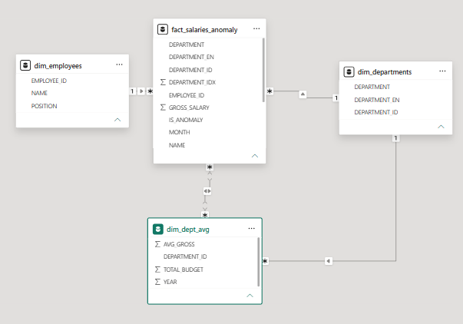
- Multidimensional Hybrid/Denormalized Star Schema for Public Sector Salary Analytics.

As shown in Fig. 4, the finalized data that resides in the Gold layer is structured into a multidimensional model to support optimized analytical querying within Power BI. This multidimensional design explicitly separates the data into quantitative metrics or Facts and descriptive attributes or Dimensions to facilitate high-speed dashboard filtering.
The model is centered around the fact_salaries_anomaly table, which houses the measurable transaction data, including GROSS_SALARY, MONTH and the DEPARTMENT_IDX encoded feature used during anomaly scoring. Crucially, this fact table also stores the IS_ANOMALY boolean indicator appended by the scikit-learn Isolation Forest model, allowing downstream analysts to immediately filter for statistically irregular compensation payouts. Because the anomaly-scoring join was implemented as an inner join rather than a left join, this fact table contains only the 3.7 million records that were actually sampled and scored, rather than the full 37 million Silver-layer transactions.
Surrounding the fact table are two primary descriptive dimensions.The dim_employees tables which holds EMPLOYEE_ID, NAME and POSITION. The dim_departments tables which holds DEPARTMENT_ID, DEPARTMENT and the DEPARTMENT_EN translation column added during implementation to support English-language reporting. A supplementary summary table, dim_dept_avg, pre-aggregates AVG_GROSS and TOTAL_BUDGET by DEPARTMENT_ID and YEAR, functioning as a departmental analytics dimension that supports high-level budget comparisons without requiring the dashboard to scan the full fact table. Temporal filtering is instead supported directly through the MONTH and YEAR fields present in the fact_salaries_anomaly and dim_dept_avg tables.
By utilizing this schema, the Power BI dashboard can efficiently slice the multi-year public sector salary metrics by specific job roles, departmental hierarchies, or temporal year-over-year trends without requiring resource-intensive table scans.

Main Interface
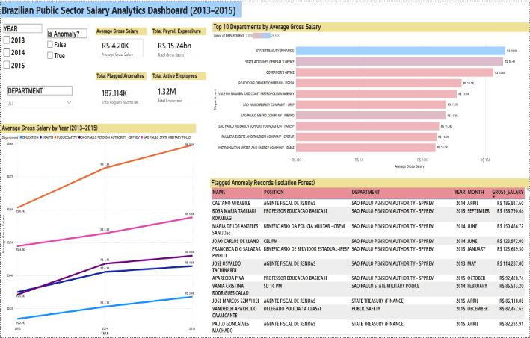
- Brazilian Public Sector Salary Analytics Dashboard (2013–2015).
The primary analytical consumption layer was realized through an interactive Power BI dashboard designed for public sector auditing, as shown in Fig. 5. Four Key Performance Indicator (KPI) cards were positioned prominently to summarize critical macro-metrics which are Average Gross Salary (R$4.20K), Total Payroll Expenditure (R$15.74bn), Total Flagged Anomalies (187.114K) and Total Active Employees (1.32M).
To visualize temporal dynamics, a line chart titled "Average Gross Salary by Year (2013–2015)" tracked year-over-year compensation trends across five representative departments: Education, Health, Public Safety, São Paulo Pension Authority (SPPREV) and São Paulo State Military Police, revealing that the Military Police maintained substantially higher average gross salaries than the other four departments across all three years.
A horizontal bar chart, "Top 10 Departments by Average Gross Salary" facilitated cross-sectional comparisons of departmental compensation, ranking departments such as the State Treasury (Finance), State Attorney General's Office and Governor's Office at the top of the pay scale.
A dedicated table, "Flagged Anomaly Records (Isolation Forest)," listed individual anomalous transactions identified by the machine learning model, displaying the employee NAME, POSITION, DEPARTMENT, YEAR, MONTH and GROSS_SALARY for each flagged record, sorted by descending salary to surface the most extreme outliers first.
Interactive slicers for YEAR (2013, 2014, 2015), Is Anomaly? (True/False) and DEPARTMENT were embedded on the left panel of the dashboard. This dynamic filtering capability empowers the Data Engineer or an external auditor to seamlessly drill down from a state-level macroeconomic view directly into specific and localized outlier transaction records.

Detailed AI Algorithm Design
- Isolation Forest Design
Item | Design
Algorithm | Isolation Forest (Unsupervised Anomaly Detection), implemented in scikit-learn on a 10% sample of the Gold-layer data and rejoined to the full PySpark DataFrame via a generated row ID
Methodology Phase | Embedded within the Implementation Phase, executed post-Gold aggregation
Input | Integrated Gold-layer salary transaction DataFrame
Features | GROSS_SALARY (float), POSITION_IDX (StringIndexer-encoded), DEPARTMENT_IDX (StringIndexer-encoded)
Preparation | Null handling via dropna(); StringIndexer encoding for categorical fields (POSITION_IDX,DEPARTMENT_IDX); features combined with GROSS_SALARY into a pandas DataFrame via .toPandas() for scikit-learn input.
Model Parameters | n_estimators=100; contamination=0.05; random_state=42
Model Tuning | Iterative adjustment of contamination threshold based on anomaly score distribution review
Evaluation | Domain-logic review of flagged records; cross-check against departmental salary norms
Output | IS_ANOMALY boolean column appended to Gold-layer Parquet, partitioned by YEAR
Consumption | Power BI anomaly slicer and audit table for human reviewer investigation

The integrated Gold-layer dataset serves as the foundational input for the anomaly detection model, where each record represents a distinct monthly salary payout. The selected quantitative and categorical features which are the standardized gross salary alongside StringIndexer-encoded representations of the employee's role and department, were extracted from the sampled Spark DataFrame and converted into a pandas DataFrame via .toPandas() for model input. The unsupervised Isolation Forest model is then trained on this in-memory feature matrix.
Because anomaly detection relies on identifying statistical isolation rather than grouping similar data points, the model's contamination parameter which is the expected proportion of outliers and tree depth were iteratively tuned. The final configuration was evaluated based on the logical distribution of the generated anomaly scores. Ultimately, a definitive boolean flag, is_anomaly was appended to the most statistically isolated records, explicitly marking these suspicious public sector payouts for human review.

Testing Plan
- Testing Plan
Test | Purpose | Expected Result
Source Extraction | Verify Kaggle dataset availability. | The three annual CSV files (2013-2015) is successfully loaded into the Colab environment
Schema Enforcement | Validate input structures during ingestion. | PySpark StructType is strictly applied without data loss or type coercion errors.
Data Type Conversion | Check BRL currency formatting logic. | Comma-separated monetary strings is successfully parsed and cast to standard floats.
Deduplication | Verify redundant record removal. | Exact duplicate transaction rows is identified and successfully dropped from the DataFrames.
Surrogate Keys | Check programmatic identifier generation. | EMPLOYEE_ID and DEPARTMENT_ID is successfully hashed and appended to the schema.
Lakehouse Storage | Validate Medallion persistence. | Parquet files are successfully written to the respective Bronze, Silver and Gold directories.
Aggregation Logic | Verify department budget calculations. | Summarized Power BI metrics perfectly aligns with the underlying granular transaction data.
AI Execution | Check Isolation Forest processing. | Anomaly scores is successfully generated without throwing vectorization runtime errors.
Dashboard Integration | Verify Power BI connectivity. | Final Gold Parquet files are smoothly ingested and accurately visualized within the BI interface.

To ensure the reliability, accuracy and structural integrity of the processed public sector data, a comprehensive testing strategy was executed systematically across all phases of the pipeline. Testing occurs incrementally as the data transitions through the Medallion architecture. Initial validation focuses on ingestion integrity, verifying that the multi-year Kaggle datasets are successfully extracted and that explicit PySpark schema enforcement prevents data loss or type coercion. A contamination threshold of 0.05 is selected as a conservative initial estimate which was iteratively reviewed against the anomaly score distribution during testing. During the transformation phase, data quality checks confirms the successful programmatic standardization of BRL currency strings and the precise removal of duplicate records.

A critical component of this testing phase involves join-integrity validation which means row counts are rigorously monitored before and after the application of the engineered surrogate keys, to guarantee that financial transaction rows are not inadvertently multiplied during table merges. Furthermore, the scikit-learn Isolation Forest model was evaluated to confirm that feature vectorization executes successfully and that anomaly flags are correctly appended without disrupting the distributed workflow. Finally, end-to-end integration was tested by verifying that the Gold layer Parquet partitions load seamlessly into Power BI. The specific testing parameters and expected outcomes are detailed in Table IV.

Conclusion

Results
The three Brazilian public sector salary datasets (2013–2015) were successfully processed through all three Medallion layers. The Bronze layer preserved an average of 11,617,364 raw records per year and the combined Silver layer, after deduplication, null-filtering, currency standardization and department translation joins, resulted in 37,409,968 cleaned records.
Due to driver memory limitations in Google Colab, the Isolation Forest anomaly detection module was applied to a random 10% sample of the integrated Gold-layer features, producing 3,742,269 scored records. Of these, 187,114 were flagged as anomalous (IS_ANOMALY = True), about 5% of the sample, matching the configured contamination parameter. Because the results were rejoined via an inner join, only the 3.74 million scored transactions, not the full 37.4 million Silver-layer records, were persisted to the final fact_salaries_anomaly output.
The four Gold-layer CSV exports were created using Spark-native .coalesce(1).write.csv() operations and verified for file existence, which includes fact_salaries_anomaly.csv ,dim_employees.csv, dept_avg.csv and dim_departments.csv.
These outputs fed a Power BI dashboard built on the hybrid/denormalized star schema outlined in Section IV. KPI cards showed an average gross salary of R$4.20K, total payroll expenditure of R$15.74 billion, 187,114 flagged anomalies and 1.32 million active employees across the three years. The line chart comparing average gross salary by year across five representative departments showed the São Paulo State Military Police consistently earning significantly more than the other four departments (Education, Health, Public Safety and SPPREV) in all three years. The bar chart ranking departments by average gross salary placed the State Treasury (Finance), State Attorney General's Office and Governor's Office as the highest-paid, while the anomaly detail table let auditors drill into individual flagged transactions sorted by descending salary.
Join-integrity testing confirmed that row counts were unchanged after each Gold-layer integration, verifying no unintended multiplication of transaction records through the surrogate key-based joins (EMPLOYEE_ID, DEPARTMENT_ID), confirming the reliability of the hashing-based key strategy used in place of native dataset keys.

Conclusion
The goal of this project was to create and deploy a scalable, end-to-end data pipeline for multi-year public sector salary analysis in Brazil that would culminate in an AI-based module for anomaly detection and an interactive Power BI dashboard. The pipeline achieved this by using an Isolation Forest anomaly detection algorithm to flag 187,114 salary records as statistically irregular, successfully processing about 37.4 million salary records using a Medallion Bronze-Silver-Gold architecture and providing a working multidimensional model to analyze salaries by department and time.
The following deviations were necessary in the implementation and are documented in this report: the random sampling strategy was changed from a full volume to 10% at the Artificial Intelligence stage; a translation column DEPARTMENT_EN was added to the dim_departments table (this column wasn't specified in the original design); a row-identification strategy was used (monotonically_increasing_id()); the implementation did not include a separate Dim_Time table but used the direct MONTH and YEAR fields. These deviations are intentional, well thought-out engineering choices that are made based on the practical limits of the Google Colab environment and do not indicate that the original design was flawed.
The resulting Gold-layer model is actually a hybrid/denormalized star schema because of the fact that the department columns are kept denormalized in the fact table and the summary table (dim_dept_avg) is pre-aggregated with a different grain. This is in line with the project's focus on the performance of dashboard queries rather than strict normalization.
Overall, the pipeline highlights the effectiveness of industry-aligned big data engineering practices, distributed processing, a Medallion Lakehouse architecture and unsupervised machine learning for assessing data quality for open-government payroll data to support transparency and auditability goals. Future work may involve running the entire unsampled set of data through a distributed version of the anomaly detection method, adding more annual releases beyond 2015, or expanding the categorical translation coverage to the POSITION field (which was out of scope for the current implementation because it has 4,452 distinct values).

References

- E. Dritsas and M. Trigka, “Applying Machine Learning on Big Data With Apache Spark,” IEEE Access, vol. 13, pp. 53377–53391, 2025. DOI: 10.1109/ACCESS.2025.3552042.
- M. Kleppmann, Designing Data-Intensive Applications: The Big Ideas Behind Reliable, Scalable and Maintainable Systems. Sebastopol, CA: O’Reilly Media, 2017.
- Z. Wang, J. R. Talburt, N. Wu, S. Dagtas and M. N. Zozus, “A Rule-Based Data Quality Assessment System for Electronic Health Record Data,” Applied Clinical Informatics, vol. 11, no. 4, pp. 622–634, 2020. DOI: 10.1055/s-0040-1715567.
- M. Armbrust, A. Ghodsi, R. Xin and M. Zaharia, “Lakehouse: A New Generation of Open Platforms that Unify Data Warehousing and Advanced Analytics,” in Proc. 11th CIDR Conf., 2021. [Online]. Available: https://www.cidrdb.org.
- A. R. Hevner, S. T. March, J. Park and S. Ram, “Design Science in Information Systems Research,” MIS Quarterly, vol. 28, no. 1, pp. 75–105, 2004.
- B. Ambrozim, “Public Employees Salaries from Brazil–São Paulo,” Kaggle, 2021. [Online]. Available: https://www.kaggle.com/datasets/bambrozim/public-employees-salaries-from-brazilsp-2012. [Accessed: Jun. 2026].
- M. Zaharia et al., “Apache Spark: A Unified Engine for Big Data Processing,” Communications of the ACM, vol. 59, no. 11, pp. 56–65, 2016. DOI: 10.1145/2934664
- C. Qin, H. Zhu, C. Zhu, T. Xu, F. Zhuang, C. Ma, J. Zhang and H. Xiong, "A Comprehensive Survey of Artificial Intelligence Techniques for Talent Analytics," arXiv preprint arXiv:2307.03195, 2023.
- F. T. Liu, K. M. Ting and Z.-H. Zhou, "Isolation Forest," in Proc. 8th IEEE Int. Conf. on Data Mining (ICDM), 2008, pp. 413–422. DOI: 10.1109/ICDM.2008.17.
- W. W. Royce, "Managing the Development of Large Software Systems," in Proc. IEEE WESCON, 1970, pp. 1–9.

APPENDIX A
PROJECT TIMELINE GANTT CHART
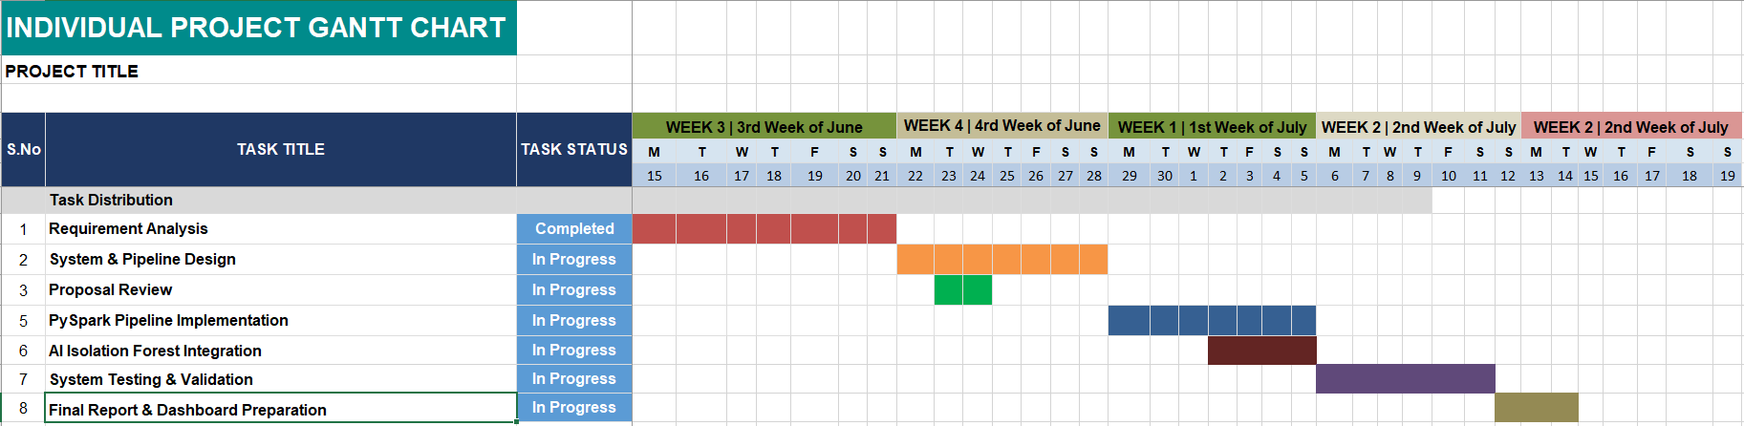
APPENDIX B
PROJECT ACTIVITY LOG
Date | Phase | Activity Description | Expected Output | Status
15 June 2026 | Requirements Analysis | Extracted and profiled the 2013–2015 Brazilian Public Sector Salary CSVs from Kaggle. | Verified dataset scope and identified missing primary keys. | Completed
22 June 2026 | System Design | Designed the Medallion Data Lakehouse architecture and surrogate key mapping logic. | Finalized data architecture and UML entity-relationship diagrams. | Completed
23 June 2026 | Proposal Review | Compiled introduction, literature review and methodology into the UTM template. | Comprehensive draft proposal document. | Completed
29 June 2026 | PySpark Pipeline Implementation | Write PySpark scripts for Bronze extraction and Silver data cleansing (BRL formatting). | Cleaned Parquet files with generated surrogate keys. | Completed
2 July 2026 | AI Isolation Forest Integration | Train and evaluate the scikit-learn Isolation Forest model on a sampled subset of Gold layer features, rejoined via generated row ID. | Anomaly-flagged analytical dataset. | Completed
6 July 2026 | System Testing & Validation | Execute join-integrity and aggregation tests; connect final Parquet files to Power BI. | Validated analytics dashboard. | Completed
12 July 2026 | Final Report & Dashboard Preparation | Conduct final checking of format and preparing meaningful visualisation | Dashboards with key business insights | Completed

